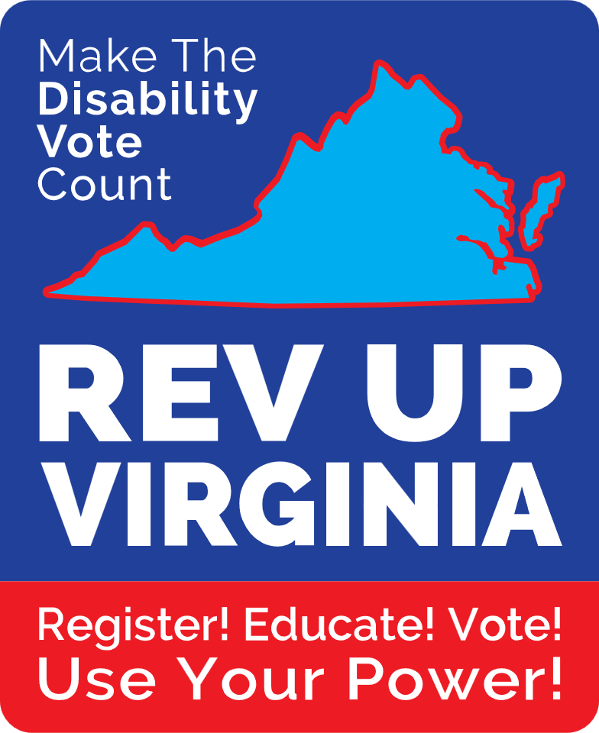

For Immediate Release

REV UP Virginia Shows the Voting Power of 1.6 Million Disabled Virginians as 20 Disability Organizations Rally Legislators in Virginia’s Capitol

Richmond, VA (October 4, 2023) – In a significant move, REV UP Virginia, a non-partisan statewide voting coalition dedicated to mobilizing and growing the disability vote, took center stage today with a compelling press conference. Today’s mission was to shed light on the nearly 25%, or approximately 1.6 million adults with disabilities in Virginia and to urge legislators to address their pressing concerns. Among the key issues raised are the expansion of voting access, preservation of Virginia's 45-day early voting period, enhanced curbside voting accommodations, inclusion of people with disabilities in emergency preparedness planning, and tackling the formidable barriers to employment faced by this demographic. The call for action couldn't be timelier as a recent study was released by the U.S. Election Assistance Commission, in conjunction with Rutgers University, that shows in the 2022 mid-term election, disabled and non-disabled Virginians voted at the same rate (53.2%).

“Our efforts across the Commonwealth are helping to further reduce the uncertainty and hesitancy that many disabled voters may still feel about casting their ballot,” added Helena Berger, co-founder and co-chair of REV UP Virginia. “With over 15 percent of the Virginia electorate disabled voters, this constituency is too sizable to be overlooked, especially when razor-thin majorities are deciding many national, state, and local elections. The time has come for all elected officials, and those running for office, to address the concerns of their disabled constituents and recognize the power of their vote.”

During this year’s elections, on November 7, 2023, Virginia voters with disabilities have a unique opportunity to demonstrate the power of their vote, with all 40 seats of the Virginia Senate and all 100 seats of the Virginia House of Delegates being up for election. The Americans with Disabilities Act requires state and local governments to ensure that people with disabilities have a full and equal opportunity to vote. There is still work to be done. In 2022, the disAbility Law Center of Virginia (dLCV) completed 500 polling site surveys in cities and counties around the state on Election Day to determine if sites are accessible. The analysis confirmed that approximately 20% of the sites did not have appropriate curbside voting signs, 13% did not have an accessible pathway to the door, and 21% did not have an accessible door that could be opened with a closed fist.

According to Christina Brookman, a speaker at today’s event and Host of Speaking in Spoons: A Chronically ill Podcast, “Disability can be very isolating and make you feel powerless. I have often felt unheard, unseen, and uninvited to the party. Participating in REV UP Virginia’s event, I got to meet incredible advocates passionate about disability rights. Hearing their stories, I felt less alone and so in awe of the work that has already been accomplished. I believe our stories, our combined passion will help remind voters of how powerful people with disabilities are, especially when we work together. Legislators will hear how loud we can make ourselves; they will come to understand our voices will not be ignored. We do vote, we will vote, and we will continue to make change happen.”

The following organizations participated in today’s event: 6 Wheels Consulting, American Parkinson Disease Association, Brain Injury Association of Virginia, Disability Disrupters, disAbility Law Center of Virginia, League of Women Voters, National Federation of the Blind of Virginia, Partnership for People with Disabilities, Resources for Independent Living, Speaking in Spoons podcast, Sportable, The Arc of Virginia, United Methodist Church Commission on Disabilities, United Spinal Association, Virginia Board for People with Disabilities, Virginia Centers for Independent Living, Virginia Down Syndrome Association, Virginia Interfaith Center for Public Policy, Vocal Virginia, and VOICE.

###

About REV UP Virginia
REV Up (Register, Educate, Vote, Use your Power) Virginia is a non-partisan voter education and engagement initiative aimed at increasing the power and influence of the disability vote to help effectuate meaningful change in the lives of disabled Virginians and their families. This statewide disability coalition, launched in April 2021, is comprised of interested individuals as well as representatives from diverse disability organizations and ally groups who are working collectively to advance the disability vote in the Commonwealth. REV UP Virginia is part of the national REV UP Campaign coordinated by the American Association of People with Disabilities. To learn more and to volunteer, visit REV UP Virginia on Facebook at www.facebook.com/REVUPVirginia or on Instagram at www.instagram.com/revupva.

Media Contacts:
Helena Berger Susan Lydick
202-573-1271 or helenaberger@verizon.net 703-328-4421 or selydick@aol.com

